|  |  |
| --- | --- |
| **Ex. No. 5** | **JAVASCRIPT – DOM ELEMENTS AND EVENTS** |
| **Date of Exercise** | 22-8-2022 |
| **Web Host Link** | https://github.com/alanjac007/web-tech-2022/tree/main/Exp%205 |
| **YouTube Link** |  |

# Aim:

To create a web pages demonstrating the applications of document object model and events in JavaScript.

# Description:

**Document Object Model:**

A Document object represents the HTML document displayed in that window. The Document object has various properties that refer to other objects which allow access to and modification of document content. The way documented content is accessed and modified is called the Document Object Model, or DOM.

# Finding HTML Element:

var myElement = document.getElementById("intro");

Finding HTML Elements by Tag Name

var x = document.getElementsByTagName("p");

Finding HTML Elements by Class Name

var x = document.getElementsByClassName("intro");

Finding HTML Elements by CSS Selectors var x = document.querySelectorAll("p.intro"); Attach event handler to the document document.addEventListener("click", function()

{

document.getElementById("demo").innerHTML = "Karunya";

});

# JavaScript Events:

JavaScript's interaction with HTML is handled through events that occur when the user or the browser manipulates a page.

|  |  |
| --- | --- |
| **Event** | **Description** |
| Onabort | Triggers on an abort event |
| Onblur | Triggers when the window loses focus |
| Onchange | Triggers when an element changes |
| Onclick | Triggers on a mouse click |
| Ondblclick | Triggers on a mouse double-click |
| Ondrag | Triggers when an element is dragged |
| Onfocus | Triggers when the window gets focus |
| Onkeyup | Triggers when a key is released |
| Onload | Triggers when the document loads |
| Onkeydown | Triggers when a key is pressed |
| Onkeypress | Triggers when a key is pressed and released |
| Onmousedown | Triggers when a mouse button is pressed |
| Onmousemove | Triggers when the mouse pointer moves |
| Onmouseout | Triggers when the mouse pointer moves out of an element |
| Onmouseover | Triggers when the mouse pointer moves over an element |
| Onmouseup | Triggers when a mouse button is released |
| Onmousedown | Triggers when a mouse button is pressed |
| Onresize | Triggers when the window is resized |
| Onscroll | Triggers when an element's scrollbar is being scrolled |
| Onresize | Triggers when the window is resized |
| Onscroll | Triggers when an element's scrollbar is being scrolled |
| Onsubmit | Triggers when a form is submitted |
| Onunload | Triggers when the user leaves the document |

# Program:

1. Write a function that accepts a string as a parameter and find the shortest and longest word within the string.

HTML file

<!DOCTYPE html>

<html lang="en">

<head>

<meta charset="UTF-8">

<meta http-equiv="X-UA-Compatible" content="IE=edge">

<meta name="viewport" content="width=device-width, initial-scale=1.0">

<title>Exercise 5</title>

<script src="script.js"></script>

<link rel="shortcut icon" href="media/icon.ico" type="image/x-icon">

</head>

<body>

<fieldset>

<legend><h1>Shortest-Longest Word!</h1></legend> String: <input id="string" type="text"><br><br>

<button type="submit" onclick="string()">Find</button> <br>

<p id="outputmin"></p>

<p id="outputmax"></p>

<a href="second.html">Next question!</a>

</fieldset>

</body>

</html>

1. Design a BMI calculator HTML file

<!DOCTYPE html>

<html lang="en">

<head>

<meta charset="UTF-8">

<meta http-equiv="X-UA-Compatible" content="IE=edge">

<meta name="viewport" content="width=device-width, initial-scale=1.0">

<title>Exercise 5</title>

<script src="script.js"></script>

<link rel="shortcut icon" href="media/icon.ico" type="image/x-icon">

</head>

<body>

<fieldset>

<legend><h1>Calculate your BMI!</h1></legend>

Weight (in kgs): <input id="weight" type="text"><br><br> Height (in cms): <input id="height" type="text"><br><br>

<button onclick="bmi()">Calculate</button><br>

<p id="bmi"></p>

<p id="result"></p>

<a href="index.html">Previous question!</a>&nbsp;

<a href="third.html">Next question!</a>

</fieldset>

</body>

</html>

1. Fruit Farm: When you click the “Plant Garden” button, the page should generate a rectangular grid of fruit images in the div with the id of “garden.” The dimensions of grid are given by the values entered in the text boxes.

HTML file

<!DOCTYPE html>

<html lang="en">

<head>

<meta charset="UTF-8">

<meta http-equiv="X-UA-Compatible" content="IE=edge">

<meta name="viewport" content="width=device-width, initial-scale=1.0">

<title>Exercise 5</title>

<script src="script.js"></script>

<link rel="shortcut icon" href="media/icon.ico" type="image/x-icon">

</head>

<body>

<fieldset>

<legend><h1>Fruit Farm!</h1></legend> Rows: <input id="rows" type="text"><br><br>

Columns: <input id="cols" type="text"><br><br>

<button onclick="grow()">Plant Garden</button><br><br>

<div id="garden"></div><br>

<a href="second.html">Previous question!</a>&nbsp;

<a href="fourth.html">Next question!</a>

</fieldset>

</body>

</html>

1. Currency convertor from USD to INR and vice versa. HTML file

<!DOCTYPE html>

<html lang="en">

<head>

<meta charset="UTF-8">

<meta http-equiv="X-UA-Compatible" content="IE=edge">

<meta name="viewport" content="width=device-width, initial-scale=1.0">

<title>Exercise 5</title>

<script src="script.js"></script>

<link rel="shortcut icon" href="media/icon.ico" type="image/x-icon">

</head>

<body>

<fieldset>

<legend><h1>Currency Convertor!</h1></legend> Convert <input type="text" id="amt">

<select id="from">

<option value="USD">USD</option>

<option value="INR">INR</option>

</select> to

<select id ="to">

<option value="INR">INR</option>

<option value="USD">USD</option>

</select><br><br>

<button onclick="convert()">Convert</button><br><br>

<span id="answer"></span><br><br>

<a href="third.html">Previous question!</a>&nbsp;

<a href="fifth.html">Next question!</a>

</fieldset>

</body>

</html>

1. Write JavaScript code to randomly change the src of the img in the HTML snippet to “heads.jpg” or “tails.jpg” when the “Flip!” button is pressed.

HTML file

<!DOCTYPE html>

<html lang="en">

<head>

<meta charset="UTF-8">

<meta http-equiv="X-UA-Compatible" content="IE=edge">

<meta name="viewport" content="width=device-width, initial-scale=1.0">

<title>Fifth</title>

<script src="script.js"></script>

<link rel="shortcut icon" href="media/icon.ico" type="image/x-icon">

</head>

<body>

<fieldset>

<legend><h1>Heads or Tails?</h1></legend>

<div>

<figure><img src="media/toss.png" onclick="flip()" id="coin" height="300px" width="300px"><br>

<figcaption style="position: relative; left: 95px;"><small>Click image to toss!</small></figcaption></figure>

</div></span>

<p>

Heads Total: <span id="num_heads">0</span><br><br> Tails Total: <span id="num_tails">0</span><br><br>

<a href="fourth.html">Previous question!</a>&nbsp;

<a href="sixth.html">Next question!</a>

</p>

</fieldset>

</body>

</html>

1. Birthday Cake order form with additional tax and tips. HTML file

<!DOCTYPE html>

<html lang="en">

<head>

<meta charset="UTF-8">

<meta http-equiv="X-UA-Compatible" content="IE=edge">

<meta name="viewport" content="width=device-width, initial-scale=1.0">

<title>Fifth</title>

<script src="script.js"></script>

<link rel="shortcut icon" href="media/icon.ico" type="image/x-icon">

</head>

<body>

<fieldset>

<legend><h1>Birthday Cake Order Form</h1></legend>

# 1/2kg Cakes:&nbsp; <input type="text" id="small"><br><br> # 1kg Cakes:&nbsp; <input type="text" id="medium"><br><br> # 2kg Cakes:&nbsp; <input type="text" id="large"><br><br> Tip:

<label><input type="radio" value="10" name="tip">10%</label>

<label><input type="radio" value="15" name="tip" checked="checked">15%</label>

<label><input type="radio" value="20" name="tip">20%</label><br><br>

<button id="submit" onclick="bill()">Calculate price</button><br><br>

<span id="price"></span><br><br>

<a href="fifth.html">Previous question!</a>

</fieldset>

</body>

</html>

# JAVASCRIPT file

function string() {

var str = document.getElementById("string").value; var l = str.split(' ');

var minstr = []; var maxstr = [];

var max = Number.MIN_VALUE; var min = Number.MAX_VALUE;

for (var i = 0; i < l.length; i++) {

if (l[i].length < min) min = l[i].length; if (l[i].length > max) max = l[i].length;

}

for (var i = 0; i < l.length; i++) {

if (l[i].length == min) minstr.push(l[i]); if (l[i].length == max) maxstr.push(l[i]);

}

document.getElementById("outputmin").innerHTML = "Shortest word(s): " + minstr.toString();

document.getElementById("outputmax").innerHTML = "Longest word(s): " + maxstr.toString();

}

function bmi() {

var h = parseFloat(document.getElementById("height").value)/100; var w = parseFloat(document.getElementById("weight").value);

var bmi = w / (h * h); var result;

if (bmi < 18) result = "Underweight";

else if (bmi >= 18 && bmi < 25) result = "Normal"; else if (bmi >= 25 && bmi < 30) result = "Overweight"; else result = "Obese";

document.getElementById("bmi").innerHTML = "BMI: " + bmi.toPrecision(4); document.getElementById("result").innerHTML = "Result: You are " + result +

"!";

}

function grow() {

var r = parseInt(document.getElementById("rows").value); var c = parseInt(document.getElementById("cols").value); var l = ["media/apple.png", "media/orange.png"];

//document.getElementById("garden").innerHTML = null; var garden = document.getElementById("garden");

for (let i = 0; i < r; i++) { for (let j = 0; j < c; j++) {

var fruit = Math.floor(Math.random() * 2);

var img = '<img src=' + l[fruit] + ' width = "150px" height = "150px"></img>';

garden.innerHTML += img;

}garden.innerHTML += "<br>";

}

}

function convert() {

var amt = parseFloat(document.getElementById("amt").value); var from = document.getElementById("from").value;

var to = document.getElementById("to").value; var ans = document.getElementById("answer");

var toINR = 79.97; var toUSD = 0.013; var result;

if (from == to) result = amt;

else if (from == "USD") result = amt*toINR; else result = amt*toUSD;

//alert(result);

ans.innerHTML = amt.toString() + " " + from + " = " + result.toString() + " "

+ to + "!";

}

function flip() {

var img = document.getElementById("coin");

var head = document.getElementById("num_heads"); var tail = document.getElementById("num_tails"); var h = parseInt(head.innerHTML);

var t = parseInt(tail.innerHTML);

var l = ["head.png", "tail.png"]; var s = Math.floor(Math.random()*2); if (l[s]==l[0]) {

head.innerHTML = h+1;

} else {

tail.innerHTML = t+1;

};

img.src = "media/"+l[s];

}

function bill() {

var half = parseInt(document.getElementById("small").value); var one = parseInt(document.getElementById("medium").value); var two = parseInt(document.getElementById("large").value); var total;

var small = 100; var medium = 200; var large = 400;

total = (half*small) + (one*medium) + (two*large); var tax = 0.09 * total;

total += tax;

var radio = document.getElementsByName("tip"); var tip;

for (var i = 0; i < radio.length; i++) {

if (radio[i].checked) tip = ((radio[i].value)/100)*total;

}

total += tip;

document.getElementById("price").innerHTML = "Cost of order: " + total + " rupees!"

}

# Output:

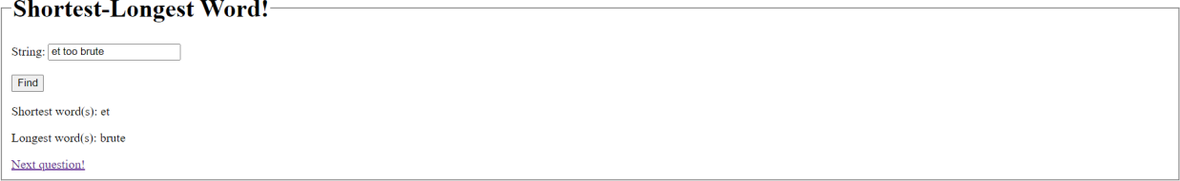

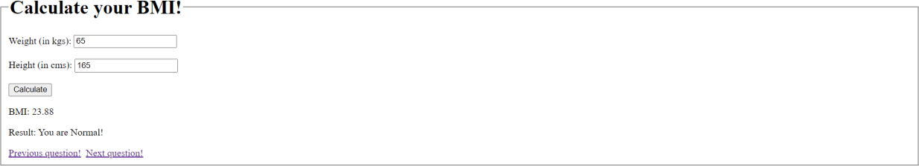

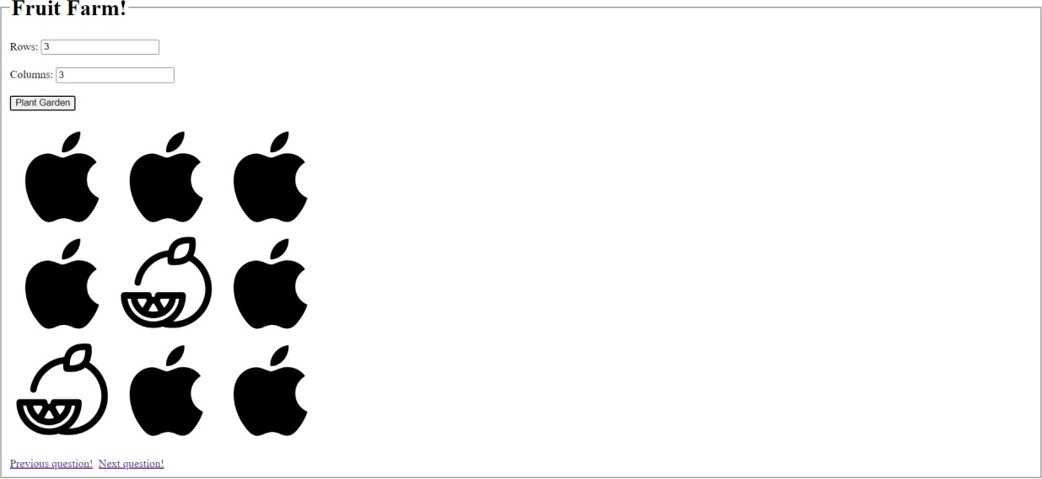

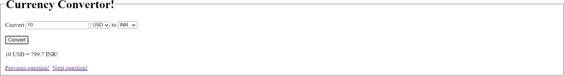

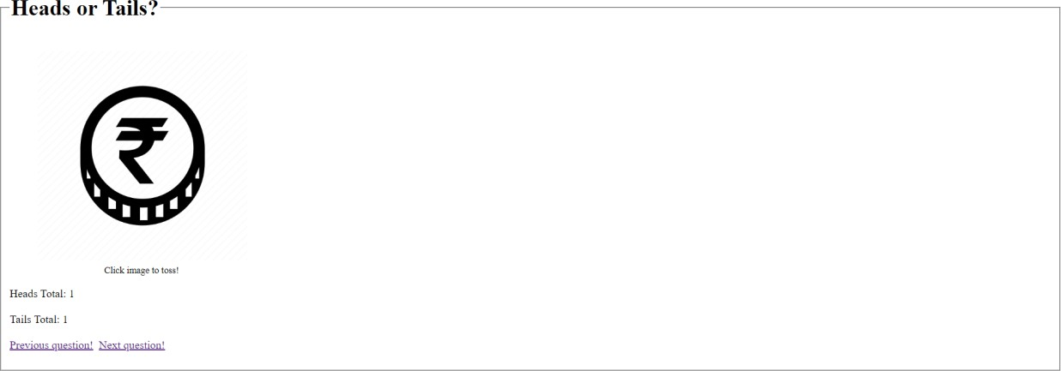

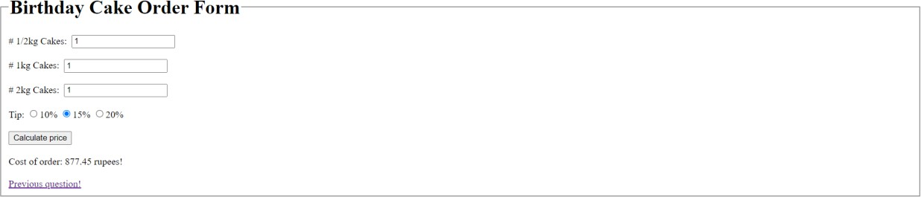

**Result:**

The website has been successfully created using JavaScript DOM elements and events.